**Gene Pools Investigation Activity**

**Your task:** Complete the gene pool activity below in class. Construct a table for your results on the space provided on this page.

**Investigation Assessment:** On Monday the 1st of May you will complete an in-class investigation validation test relating to this activity. You may bring in this sheet (with your completed results table) to use during the assessment.

**Background:** In this activity you will model the changes in a gene pool of hypothetical beetles. The beetles are naturally red, yellow or orange in colour, and are preyed upon by water birds. You will simulate the different predation rates on the three variations of beetle colour over a number of generations.

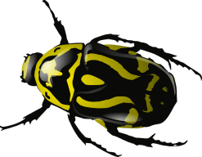**Materials:**

Coloured cards or counters – 30 red, 30 yellow and 30 orange

A die

**Procedure:**

1. Construct a table to record the number of each colour beetle over 10 generations.
2. From the pool of coloured cards, select ten of each colour; these will be your first generation of beetles. Shuffle the cards so that they are well sorted and then deal them out in pairs. You should have 15 pairs of cards representing 15 pairs of beetles.
3. Assume that each pair of beetles consists of a male and a female and that each pair produces only one offspring. The pairs produce offspring according to the following rules:

* Two red beetles produce a red offspring
* Two yellow beetles produce a yellow offspring
* A red beetle and a yellow beetle produce an orange offspring
* Two orange beetles produce an offspring colour which is decided by a throw of the die:
  + 1 = a red offspring
  + 2 = a yellow offspring
  + 3 or 4 = an orange offspring
  + 5 or 6 = throw the die again until you throw a 1, 2, 3 or 4.
* A red beetle and an orange beetle produce an offspring colour which is decided by a throw of the die:
  + 1, 2 or 3 = a red offspring
  + 4, 5 or 6 = an orange offspring
* A yellow beetle and an orange beetle produce an offspring colour which is decided by a throw of the die:
  + 1, 2 or 3 = a yellow offspring
  + 4, 5 or 6 = an orange offspring

1. Yellow and orange beetles do not camouflage as easily in their environment and therefore are more likely to be preyed upon by birds than red beetles. Simulate predation in your population of 45 beetles. Fifteen of the beetles are to be predated upon. Throw the die 15 times and for each throw remove one beetle according to the following rules:

* If 1, 2 or 3 is thrown, remove a yellow beetle.
* If a 4 or 5 are thrown remove an orange beetle.
* If a 6 is thrown remove a red beetle.

1. There should be 30 cards remaining. This is your second generation of beetles. Count the cards and record the number of each colour in your results table.
2. Shuffle the cards well and repeat steps 3, 4 and 5 to get the third generation. Record your results in the table.
3. Continue this process until all the beetles are one colour, or until you have completed ten generations.

**Results table:**

**Year 12 Biology**

**Gene Pool Investigation Validation Test**

|  |
| --- |
| Name: |
| Teacher: |

|  |  |  |
| --- | --- | --- |
| Marks Received | Marks Available | Percentage |
|  | 40 |  |

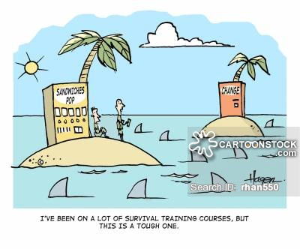

Weighting 5%

Time 50 minutes

1. Construct a table of results that shows the frequency of each colour of beetle over ten generations expressed as a decimal. (3 marks)
2. Construct a line graph of your results. (5 marks)



1. Which colour beetle was eliminated first? Explain why this occurred. (3 marks)

|  |
| --- |
|  |
|  |
|  |
|  |

1. An evolutionary mechanism is a process that results in changes in allele frequencies over a number of generations. Name the evolutionary mechanism modelled in this activity. Explain your choice. (6 marks)

|  |
| --- |
|  |
|  |
|  |
|  |
|  |
|  |
|  |
|  |
|  |
|  |
|  |
|  |
|  |

1. Rewrite the rules for predation so that if the experiment were repeated eventually a homogenous yellow population of beetles would occur. (1 marks)

|  |
| --- |
|  |
|  |
|  |

1. If there is a 100% chance of orange beetles being predated by water birds, is it still possible for orange beetles to occur in future generations? Explain your answer.

(2 marks)

|  |
| --- |
|  |
|  |
|  |

1. Explain what would happen to the composition of the beetle population over several generations if water birds preyed equally on all three colours. (2 marks)

|  |
| --- |
|  |
|  |
|  |

1. In this simulation, does the chance of survival of any *individual* beetle vary from one generation to the next? Explain your answer. (2 marks)

|  |
| --- |
|  |
|  |
|  |

1. In this simulation, does the chance of survival of the *species* vary from one generation to the next? Explain your answer. (2 marks)

|  |
| --- |
|  |
|  |
|  |

1. If the intensity of predation against beetles was altered to 4 red: 2 orange : 0 yellow, predict what changes you would expect in the results. (1 mark)

|  |
| --- |
|  |
|  |

1. Explain how you could change the rules in step 3 of the method to show non-random mating in this population. Provide an example of how this would apply to the beetle population and predict how this would change the results.

(3 marks)

|  |
| --- |
|  |
|  |
|  |
|  |
|  |
|  |
|  |
|  |

1. Biologists use population simulations to help predict changes that may occur in nature. Explain one advantage and one disadvantage of using simulations.

(4 marks)

|  |
| --- |
|  |
|  |
|  |
|  |
|  |
|  |
|  |
|  |
|  |

The two graphs below relate to Questions 13 and 14.

**Graph 1:** Mutation frequencies in a population of 10 individuals

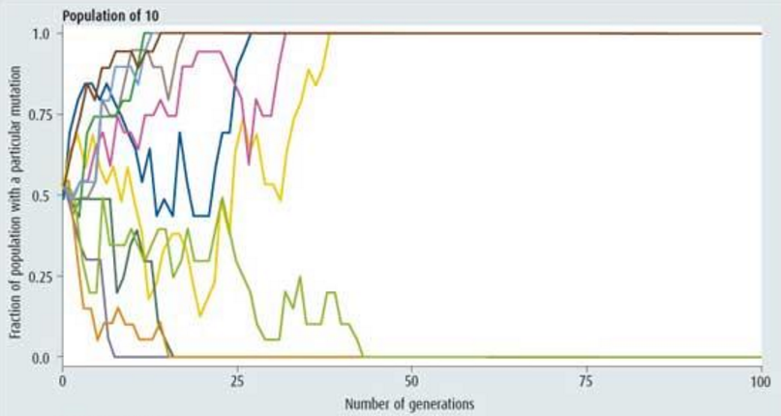

Graph 2: Mutation frequencies in a population of 100 individuals.

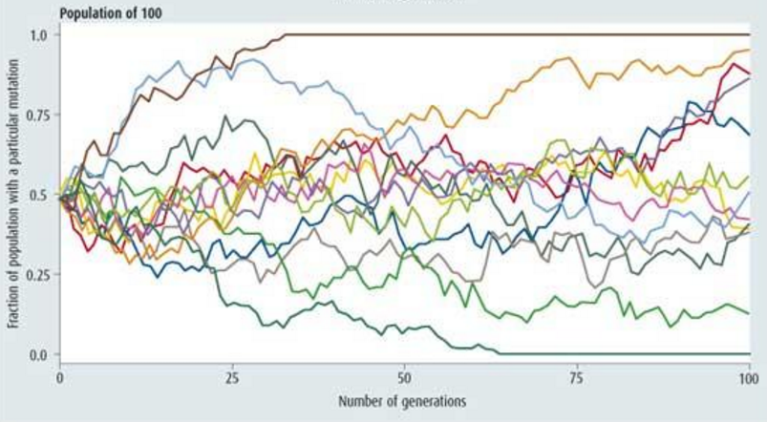

1. Each mutation shown in both graphs shows some level of fluctuation. Explain why the frequency of a mutation may fluctuation over many generations rather than just increasing to the point that it is fixed or decreasing to the point that it is eliminated. (2 marks)

|  |
| --- |
|  |
|  |
|  |
|  |

1. Compare the results from the two graphs. Discuss two similarities and two differences between the data shown in the graphs. (4 marks)

|  |
| --- |
|  |
|  |
|  |
|  |
|  |
|  |
|  |
|  |
|  |
|  |